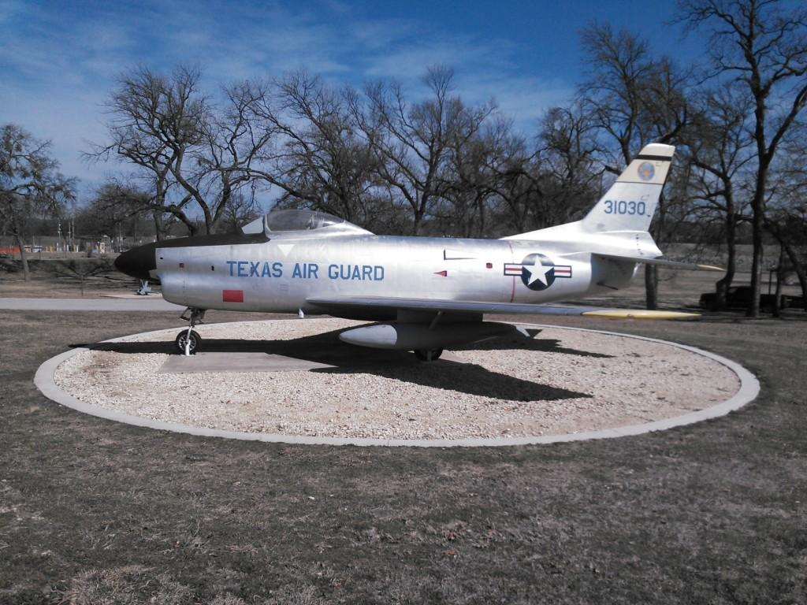

UNCLASSIFIED//FOUO

GEODETIC SURVEYS DIVISION



Publication 14-H046

Airfield Survey

NAS JRB Fort Worth, Texas

February 2014

NATIONAL GEOSPATIAL-INTELLIGENCE AGENCY

UNCLASSIFIED//FOUO

**Airfield Survey**

**NAS JRB Fort Worth**

**Texas**

February 2014

**TABLE OF CONTENTS PAGE**

1. **INTRODUCTION** **3**
2. Background **3**
3. Requester **3**
4. Survey Dates/Team Members **4**
5. **REQUIREMENTS** **4**
6. **SURVEY OPERATIONS** **4**
7. Reconnaissance **4**
8. Primary and Secondary Airfield Control Stations (PACS/SACS) **4**
9. Runway Ends, Temporary Control Points and Imagery Control Points **4**
10. Runway Profile Points **5**
11. Navigational Aids **5**
12. Obstructions **5**

**4. COMPUTATIONS AND ANALYSIS** **5**

1. PACS/SACS **5**
2. Runway Ends and Imagery Control Points .**6**
3. Runway Profile Points **6**
4. Temporary Control Points/Navigational Aids/Obstructions **6**
5. Combined Adjustment **6**

**5. SURVEY RESULTS** **7**

1. Airfield Information **7**
2. Accuracy of the WGS 84 (G1762) Coordinates **7**
3. Explanation of the WGS 84 (G1762) Reference Frame **7**
4. Explanation of Orthometric Height **8**

**6. DISCLAIMER** **8**

**7. STATION DESCRIPTIONS**  **9-11**

**8. THRESHOLD PHOTOS 12**

**9**. **EXCEL SPREADSHEET APPENDIX A**

Primary and Secondary Airfield Control Points

Imagery Control Points

Runway Profile Points

End of Runway Points

Navigational Aids

Obstructions

Additional Points

Calculated points

**10**. **IMAGERY CONTROL POINTS (Photos/Descriptions) APPENDIX B**

**Airfield Survey**

**NAS JRB Fort Worth**

**Texas**

February 2014

1. **INTRODUCTION**

a. Background

Beginning in April 1996, the U.S. Secretary of Defense issued a series of memoranda to the three branches of the military that addressed the use of Global Positioning Systems (GPS) to improve flight safety. The memoranda called for the installation of GPS systems in aircraft and the development and use of validated terminal Instrument Approach Procedures (IAP) for all airfields visited more than three times per year.

The tri-services requested help from the National Geospatial-Intelligence Agency (NGA) in meeting the requirements set forth in the memoranda. NGA has agreed to provide Primary and Secondary Airport Control Stations (PACS and SACS), Airfield Feature Data (including runway and navigational aid data), and Airfield Obstruction Data.

This report presents the results of the geodetic survey conducted at Naval Air Station (NAS) Joint Reserve Base (JRB) Fort Worth, Texas, in support of the Terminal Aeronautical Global Navigation Satellite Systems Geodetic Survey (TAGGS) Program, dated 18 January 2006. **This report supersedes the previous NAS JRB Fort Worth Survey (NGA Publication 05-6022, dated September 2005).**

b. Requester

The National Geospatial-Intelligence Agency (NGA), Office of Geomatics, Geodetic Surveys Division, undertook this geodetic survey pursuant to a request by the Naval Flight Information Group (NAVFIG) for a TAGGS airfield survey at NAS JRB Fort Worth, Texas. If you have any questions or comments pertaining to the enclosed information, please contact Mr. Bill McCord at (314)676-6658.

c. Team Members/Survey Dates

The fieldwork was accomplished during the period 4-13 February 2014 by an NGA team consisting of Mr. Michael McNeely (Team Chief), Mr. R. David Wheeler, and Mr. Lewis A. Shaw.

1. **REQUIREMENTS**

The precision and accuracy requirements are stated in Appendix B and C of the NGA Airfield Survey Specification Document for the TAGGS Program, dated August 2010.

1. **SURVEY OPERATIONS**
2. Reconnaissance

Mr. Dennis Statler, Airfield Manager, Com: 817-782-7689 located at NAS JRB Fort Worth was our point of contact. Mr. Statler greeted the team and provided information on airfield access and procedures. The existing navigational aids, runway ends, and other areas of concern were identified. Two existing survey monuments were recovered and utilized for the survey.

1. Primary and Secondary Airfield Control Stations (PACS/SACS)

A World Geodetic System (WGS) 84 absolute position was established at NGA’s Primary Airfield Control (PAC) station “KNFW 1 2014”. The station was occupied with a Trimble SPS Model 855 GPS satellite receiver for a period of 60 hours for the point positioning. Three, separate day, 6-hour session relative ties between the PAC and Secondary Airfield Control (SAC) Stations, NGA’s “KNFW A 2005” & “KNFW C 2005”, were made. GPS data was collected on the PAC and at least one SAC concurrent with all other GPS observations.

1. Runway Ends, Temporary Control Points and Imagery Control Points

WGS 84 geodetic control was extended from station “KNFW 1 2014” to all runway ends, temporary control points and imagery control points with a minimum of two static GPS sessions.

1. Runway Profile Points

The runway profile points were established by driving a vehicle, in both directions, down the centerline of the runway collecting data by continuous GPS kinematic methods at an epoch interval of 1 second. Both runs were analyzed to insure that the accuracy requirements were met and the profiles were computed to an interval of 50 feet for the publication.

1. Navigational Aids

The Rotating Beacon (BEACON), Digital Approach Surveillance Radar (DASR), Precision Approach Radar (PAR), and Tactical Air Navigation (TACAN) were positioned via intersection from at least three temporary control points. The Localizer, PAR Reflectors, Glide Slopes, Precision Approach Path Indicator (PAPI) arrays, and Approach Lights were positioned by GPS PPK methods.

1. Obstructions

Fifty-three obstructions in the general area and/or in the approach/departure zones were surveyed at NAS JRB Fort Worth.

The points were positioned via intersection from at least three temporary control points and/or by GPS RTK methods. The heights at both the top and ground level of each obstruction were determined.

1. **COMPUTATIONS AND ANALYSIS**
2. PACS/SACS

The WGS 84 position of “KNFW 1 2014” was computed using WIPPS (WGS84 & ITRF Precise Positioning Service) online software with precise ephemeris created by the Applied Research Lab (ARL UT-Austin). The adopted position was validated using National Geodetic Survey’s (NGS) Online Positioning User Service (OPUS), using precise ephemeris. The WGS 84 absolute point position of “KNFW 1 2014” was adopted as the origin of the survey.

Fixing the WGS 84 position of “KNFW 1 2014”, the delta x, y, and z components to the SACS were computed by differential processing using the Trimble Business Center (TBC) version 2.81. The results were then combined, and entered into a least squares network adjustment using the BitWise Ideas Inc. GeoLab version 2001.9.20.0 GPS network adjustment software to obtain positions.

1. Runway Ends and Imagery Control Points

Fixing the WGS 84 position of “KNFW 1 2014”, the delta x, y, and z components to the runway ends and imagery control points were computed by differential processing using TBC. The multiple sessions were combined and entered into a least squares network adjustment using GeoLab adjustment software to obtain positions.

1. Runway Profile Points

Fixing the WGS 84 positions of the PACS and SACS, the delta x, y, and z components to the kinematically observed points were computed by differential processing using TBC. The runway profile sessions were combined and entered into a least squares network adjustment using GeoLab adjustment software to obtain positions.

1. Temporary Control Points/Navigational Aids/Obstructions

Fixing the WGS 84 position of “KNFW 1 2014”, the delta x, y, and z components to multiple temporary control points were computed by differential processing using TBC. The multiple sessions were combined and least squares adjusted with GeoLab adjustment software to obtain positions of the temporary control points.

The resulting coordinates were held fixed, grouped with the conventional observations to the previously identified obstructions and navigational aids and entered into a least squares network adjustment using GeoLab adjustment software to obtain positions.

1. Combined Adjustment

A combined adjustment of the static and all conventionally surveyed points was accomplished. The multiple adjustments were merged and least squares adjusted with GeoLab adjustment software. Separate least squares adjustments of the runway profiles and kinematic GPS observations were performed using the same software. The adjusted vectors were analyzed to insure that all stations met the prescribed accuracies.

1. **SURVEY RESULTS**
2. Airfield Information

The WGS 84 latitude and longitude values listed in Appendix A were the results of GPS and conventional observations performed during the survey. The orthometric height values are the result of applying the NGA geoid models (EGM96 and EGM08) to the ellipsoid heights observed during the survey.

1. Accuracy of the WGS 84 (G1762) Coordinates

The coordinates of “KNFW 1 2014” are estimated to have a positional accuracy relative to the WGS 84 (G1762) Reference Frame of less than ±0.25 meter, one-sigma (0.41 meter, 0.9P) in each component. The results provided in this publication meet or exceed the requirements stated in Appendix B and C of the Airfield Survey Specification Document for the TAGGS program.

1. Explanation of the WGS 84 (G1762) Reference Frame

WGS 84 (G1762) is a refined reference frame that includes a new GPS realization of WGS 84 and the adoption of the International Earth Rotation Service (IERS) standard value of the product of the universal gravitational constant and the mass of the earth. This refined reference frame is coincident with the IERS Terrestrial Reference Frame 2008 (ITRF08) at a level approaching 0.1 meter.

Positional absolute accuracy statements contained within this report are based upon GPS observation sets and tidal effect models that virtually cancel any daily temporal effects. If decimeter level or better absolute accuracy is required, careful consideration must be given to these station displacements since the peak absolute, instantaneous effect can be as large as 0.420 meters (Ref. NIMA TR8350.2).

**Epoch 2014.11** indicates the time at which the GPS observations were made. Plate tectonic motion may cause changes in both the horizontal and vertical components over time. Using the epoch, the horizontal positions can be updated as needed by using the IERS plate motion model, NNR-NUVEL1A.

1. Explanation of Orthometric Height

The orthometric heights given in this publication are representative of mean sea level. Reference FAA No. 405, STANDARDS FOR AERONAUTICAL SURVEYS AND RELATED PRODUCTS. Section 1: The term mean sea level (MSL) implies orthometric height. MSL is used throughout the National Airspace System. In actuality, these altitudes are relative to a vertical datum that approximates mean sea level and are correctly referred to as orthometric heights.

1. **DISCLAIMER**

This report presents WGS 84 positional and height information, in compliance with Airfield Survey Specification Document for the TAGGS program requirements, for geodetic control stations, runways, navigation aids and many of the potential obstacles to safe approach and departure from NAS JRB Fort Worth. Please note with caution that the obstruction information presented represents only a subset of the potential obstacles in the vicinity of NAS JRB Fort Worth, and may not include all the obstacle data required for a specific application. The data in this report should be supplemented by maps, charts, and other pertinent information available (such as construction projects), and an inspection of the airfield and vicinity during the development and evaluation of Global Navigation Satellite Systemprocedures.

The mention herein of commercial products, trade names, or commercial companies does not constitute an endorsement of such products, names, or companies by the United States Government.

|  |  |  |  |  |  |
| --- | --- | --- | --- | --- | --- |
| DESCRIPTION OF GEODETIC STATI0N | | | | | |
| **STATION NAME** | | **WGS 84 Position** | | |  |
| KNFW 1 2014 | | **Lat:** 32°46’33.537”N **Long**: 97°25’50.257”W EH:157.54m | | |  |
| **LOCATION** | | | | **DESCRIBED BY** | |
| NAS JRB Fort Worth, TX | | | | McNeely | |
| **ESTABLISHED BY** | | | | **DATE** | |
| NGA/SNSH | | | | February 2014 | |
| The station is located just west of Base OPS (Bldg. 1425). The station, a standard National Geospatial-Intelligence Agency bronze disk stamped “KNFW 1 2014”, is set with rockite in the southwest corner of a square concrete pad with a manhole cover.  NOTE: This station was utilized as the Primary Airfield Control Station for the Airfield Survey conducted in February 2014. Access to the point should be coordinated with the Airfield Manager.KNFW_1.jpg | | | | | |
| DESCRIPTION OF GEODETIC STATI0N | | | | | |
| **STATION NAME** | | | **WGS 84 Position** | |  |
| KNFW A 2005 | | | **Lat:** 32°45’35.185”N **Long**:97°26’08.766”W EH:161.48m | |  |
| **LOCATION** | | | | **DESCRIBED BY** | |
| NAS JRB Fort Worth | | | | McNeely | |
| **ESTABLISHED BY** | | | | **DATE** | |
| NGA/SNSH | | | | February 2014 | |
| The station is located on the east side of the airfield, just west of the perimeter road. The station, a standard National Geospatial-Intelligence Agency bronze disk stamped “KNFW A 2005”, is set flush in the southeast corner of a rectangular concrete pad.  NOTE: This station was utilized as a Secondary Airfield Control Station for the Airfield Survey conducted in February 2014. Access to the point should be coordinated with the Airfield Manager.  KNFW_A.jpg | | | | | |
| DESCRIPTION OF GEODETIC STATI0N | | | | | |
| **STATION NAME** | **WGS 84 Position** | | | |  |
| KNFW C 2005 | **Lat:** 32°46’11.453”N **Long**: 97°26’33.646”W **EH:** 164.91m | | | |  |
| **LOCATION** | | | | **DESCRIBED BY** | |
| NAS JRB Fort Worth | | | | McNeely | |
| **ESTABLISHED BY** | | | | **DATE RECOVERED** | |
| NGA/SNSH | | | | February 2014 | |
| The station is located on the west side of the airfield, just east of the perimeter road. The station, a standard National Geospatial-Intelligence Agency bronze disk stamped “KNFW C 2005”, is set flush in an abandoned concrete taxiway.  NOTE: This station was utilized as a Secondary Airfield Control Station for the Airfield Survey conducted in February 2014. Access to the point should be coordinated with the Airfield Manager.  KNFW C1.jpg | | | | | |

|  |  |
| --- | --- |
| **THRESHOLD 18**  RUNWAY PHOTOS | |
| TH18_1.jpg  **Survey Point** | TH18_2.jpg  **Survey Point** |
| **THRESHOLD 36** | |
| TH36_1.jpg  **Survey Point** | TH36_2.jpg  **Survey Point** |